Dataset 7: Music Condition & Recall

Scenario Overview
Participants studied a word list in one of three conditions: silence, instrumental music, or music with lyrics. Recall scores (out of 20) are shown with SE error bars.

Data Summary
Condition | Mean recall score (out of 20) | Error / SD
Silence | 16.8 | 0.6
Instrumental | 14.5 | 0.8
Lyrics | 11.2 | 0.7

Figure
Figure 1. Mean recall scores (±1 SE) by music condition.
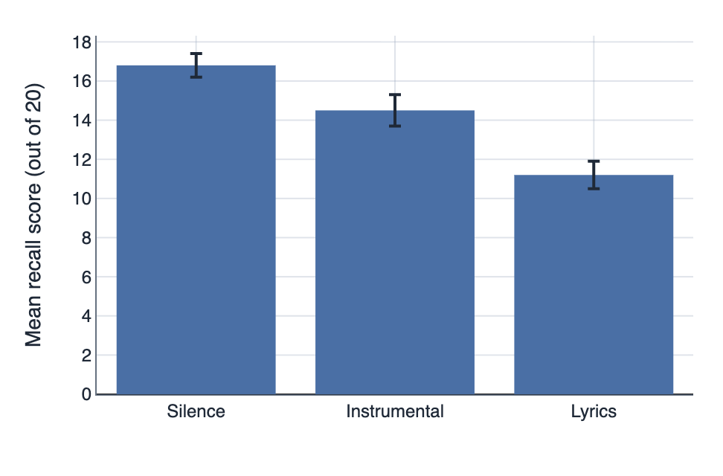

IA1 Practice Questions
- Determine: Determine the highest mean recall score.

- Calculate: Calculate the raw difference in mean recall between silence and lyrics.

- Compare: Compare and contrast the three conditions.

- Identify: Identify which pair of conditions is most similar.

- Draw: Draw a conclusion about interference and recall.

- Predict: Infer why the 'Lyrics' condition resulted in the lowest recall scores based on the concept of divided attention.

